Software homework

**Question**

**w = x;  // node 1**

**if (m>0) {**

**w++;    // node 2**

**}else{**

**w=2*w;  // node 3**

**}**

**// node 4 (no executable statement)**

**if (y<=10) {**

**x = 5*y;    // node 5**

**} else {**

**x = 3*y+5;  // node 6**

**}**

**z = w + x;  // node 7**

1. **Draw a control flow graph for this program fragment. Use the node numbers given above.**

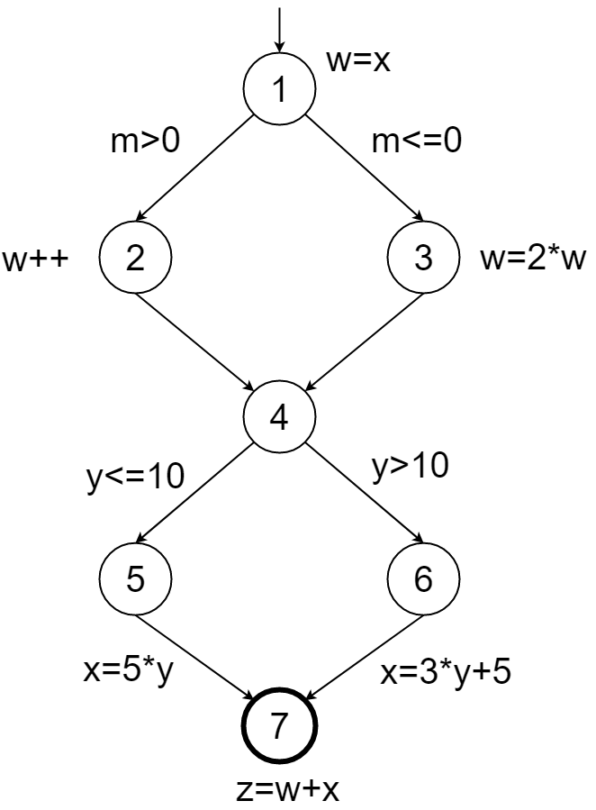

1. **Which nodes have defs for variable w?**

Node 1,2,3

1. **Which nodes have uses for variable w?**

Node 2,3,7

1. **Are there any du-paths with respect to variable w from node 1 to node 7? If not, explain why not. If any exist, show one.**

Example du-path = [1,2,4,5,7]

A du-path is a simple path where the initial node of the path is the only defining node of x in the path.

1. **Enumerate all of the du-paths for variables w and x**

Du-paths for w =

{[1,2],[1,3],[1,2,4,5,7],[1,2,4,6,7],[1,3,4,5,7],[1,3,4,6,7],[2,4,5,7],[2,4,6,7],[3,4,5,7],3,4,6,7}

Du-paths for x = {[5,7], [6,7]}